Lab Manual for Object-Oriented Programming
(LAB-10)

Multi-level and Multiple Inheritance

Table of Contents
1. Introduction 91
2. Activity Time Boxing 92
3. Objective of the Experiment 92
4. Concept Map 92
5. Homework before Lab 93
5.1 Problem Solution Modeling 93
5.2 Practices from home 93
6. Procedure & Tools 94
6.1 Tools 94
6.2 Setting-up Visual Studio 2008 94
6.3 Walkthrough Task 94
7. Practice Tasks 95
7.1 Practice Task 1 95
7.2 Outcomes 96
7.3 Testing 96
8. Evaluation Task (Unseen) 96
9. Evaluation Criteria 97
10. Further Reading 97
10.1 Books 97
10.2 Slides 97

Lab 8: Multi-level and Multiple Inheritance

Introduction
In the previous labs i.e. in [Lab 06] and [Lab 07], you have already learned that the inheritance in object-oriented programming (OOP) is the ability to transfer attributes and behaviors from base/parent class(es) to derive/child class(es). As a next step, it is essential to learn the types of inheritance on the basis of class hierarchies. Following different class hierarchies, inheritance in OOP can be categorized as

- Single Inheritance: a single child class derived from a single base class
- Hierarchical Inheritance: multiple child classes derived from a single base class
- Multi-level Inheritance: a single derived class inherited from another derived class
- Multiple Inheritance: a single derived class inherited from more than one base classes
- Hybrid Inheritance: any legal combination of more than one type of inheritance

In particular, the main focus of this lab is concerned with the understanding of multi-level and multiple inheritance. Multi-level represents the scenario of inheriting attributes and behavior of a class that is already inheriting attributes and behaviors from other class(es). The syntax of writing C++ code to implement multi-level class hierarchy is given as under:

class X
{
// code statements go here
};
class Y: public X
{
//code statements go here
};
class Z: public Y
{
//code statements go here
};
...

There is no limitation on the number of levels in multi-level inheritance.

Multiple Inheritance represents where a single class inherits attributes and behaviors from more than one class. The syntax to write C++ code for multiple inheritance is given as under:

class X
{
// code statements go here
};
class Y
{
//code statements go here
};
class Z: public X, public Y
{
//code statements go here
};

Relevant Lecture Readings:
- Textbook: Object-Oriented Programming Using C++, Fourth edition, Robert Lafore.
  - Pages: 399- 412

Activity Time Boxing
Table 1: Activity Time Boxing

Task No. | Activity Name | Activity time | Total Time
6.2 | Setting-up Visual Studio | 5 mins | 5 mins
6.3 | Walk-through Tasks | 30 mins | 30 mins
7 | Practice tasks | 80 mins | 80 mins
8 | Evaluation Task | 55 min for all assigned task | 55 mins
 |  | Total Time | 170 mins

Objective of the Experiment
After completing this lab, the student should be able to:
- develop multiple level class hierarchies
- derive a child class from multiple base classes
- understand the advantages of multi-level inheritance and multiple inheritance

Concept Map
Inheritance is one of the most important building blocks of OOP. The concept of reusable classes is helpful to manage objects because occasionally it happens that a class may have some features that it can derive from already existing class(es). Hence, with inheritance, it is sometimes crucial to build multi-level class hierarchies or to derive class(es) from multiple existing classes. To grasp the concept and need of multi-level and multiple inheritance, consider the following class hierarchy
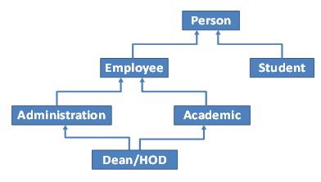
Figure 1: Class Hierarchies showing Multi-level and Multiple Inheritance

A person can be an employee or a student. An employee may have rights of admin officer or of academic officer. These class hierarchies represent multi-level inheritance. However, a Dean or Head of Department (HOD) may have rights to modify the status already defined by an admin or academic officer. This type of relationship between classes is an example of multiple inheritance.

C++ facilitates users while supporting the implementation of both multi-level and multiple inheritance. There is no limitation on the number of levels in multi-level inheritance and there is no limitation on the number of parent classes from which a child can be derived. Nevertheless, as a good practice, it is recommended to restrict levels and number of base classes to two in multi-level and multiple inheritance.

Homework before Lab

Problem Solution Modeling
Draw UML class diagrams of the following task. You are required to bring this design with you and submit to your lab instructor.

5.1.1 Problem description:

Design a class named Staff that includes
- A data member named staffID
- A parameterized constructor to initialize staffID
- A getter function to get the value of staffID
Derive a class named Professor inherited from Staff class and contains
- Two additional data members i.e. departmentID and departmentName
- A parameterized constructor to initialize its own data fields along with the inherited data field
- Two getter functions that return the departmentID and departmentName, respectively
Derive a class named VisitingProfessor inherited from class Professor and has
- A data field named no_of_courses
- A data field named salary_per_course
- A function named totalSalary that returns total payment for all courses (i.e. no_of_courses * salary_per_course)
- A member function named display to show total salary of visiting professor

Draw UML diagram for each class and show inheritance relationship between these classes.

Practices from home
5.2.1 Task-1

Consider the problem description of section 5.1.1 of this lab that deals with three classes i.e. Staff, Professor, and VisitingProfessor. Implement all these classes and in the main function, create an object of class VisitingProfessor and invoke its member function display to show total income of a visiting professor.

5.2.2 Task-2

Consider four classes named Animal, Mammal, Bird, and Bat.
- class Animal that includes the functionality of eating and breathing
- class Mammal derived from Animal class and has additional functionality of giving birth but not hatching
- class Bird derived from Animal class and has specific functionality of flying
- class Bat derived from both Animal and Bird classes while inheriting the functionality of both these classes

Draw UML diagram for each class and show inheritance relationship between these classes. Moreover, illustrate the implementation of these classes in C++.

Procedure & Tools

Tools
Visual Studio 2008.

Setting-up Visual Studio 2008 [Expected time = 5 mins]
Setup visual studio and make a project named “MultipleInheritance”

Walkthrough Task [Expected time = 30 mins]
In this task, you are required to write a C++ code which would elaborate multiple-inheritance concept. The following lines show the output of a basic multiple-inheritance concept:

6.3.1 Writing Code
In the source file, which is created in the project “MultipleInheritance” write following C++ code:

#include<iostream>
using namespace std;

class Student
{
protected:
int registrationNum,marks1,marks2;
public:
void getMarks()
{
cout<<"Enter the Registration number: ";
cin>>registrationNum;
cout<<"Enter the marks: ";
cin>>marks1;
cin>>marks2;
}
};
class SportActivity
{
protected:
int sportsmarks;
public:
void getSportsMarks()
{
cout<<"\nEnter the marks for sports: ";
cin>>sportsmarks;

}
};
class MarksStatment:public Student,public SportActivity
{
int totalMarks,averageMarks;
public:
void ShowStatement()
{
totalMarks=(marks1+marks2+sportsmarks);
averageMarks=totalMarks/3;
cout<<"\ntRegistrattion Number: "<<registrationNum<<"\nTotal marks: "
<<totalMarks;
cout<<"\nAvergae marks : "<<averageMarks;
}
};

Figure 1: Multiple Inheritance

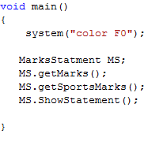
Figure 2: Main function for Figure 1
6.3.2 Compilation
After writing the code, compile your code according to the guidelines mentioned. Remove any errors and warnings that are present in your code.
6.3.3 Executing the Program
A sample output after running the program is shown below:

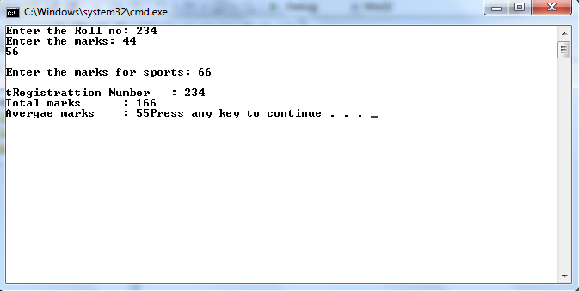
Figure 3: Final Output

Practice Tasks
This section will provide more practice exercises which you need to finish during the lab. You need to finish the tasks in the required time. When you finish them, put these tasks in the following folder:
\\dataserver\assignments$\OOP\Lab8

Practice Task 1 [Expected Time = 80 mins]
Consider the following details of all classes for class hierarchy shown in Figure 1 of this lab.

- Class Person holds
  - Two attributes i.e. name and year_of_birth
  - A two-argument constructor to initialize its data members with user-defined values

- Class Employee contains
  - Five attributes i.e. employeeID, joiningYear, jobTitle (designation of an employee), courseID, and courseTitle

- Class Administration has
  - A parameterized constructor to receive five arguments to initialize inherited attributes from class Employee
(Concerning courseID and courseTitle, only null value is allowed to set for an admin officer)
  - Two functions i.e. setJobTitle(employee) and getJobTitle(employee) to set and get job title of an employee

- Class Student has
  - Two attributes i.e. studentID and enrolledSemester
  - A four-argument constructor to initialize its data members (including inherited data members)
  - A function named display() to show the values of all attributes (including inherited attributes)

- Class Academic has
  - A parameterized constructor to receive five arguments to initialize inherited attributes from class Employee
(Concerning employeeID, joiningYear, and jobTitle, only null value is allowed to set)
  - Two functions i.e. setCourseID() and setCourseTitle()

- Only an instance of class DeanHOD should be able to modify values for employeeID, designation of an employee, ID and name of a particular course.

Implement all these classes and within the main function, create instances of all classes (except class Employee) and test the described working of all these classes.

Outcomes
After completing this lab, student will be able to understand the implementation and design of Multi-level and Multiple Inheritance in C++.

Testing
- For Practice Task 1, while inspecting implementation of classes, lab instructor must ensure that student has taken hold the concept of multi-level and multiple inheritance. Furthermore, it is required to check the invocation of all functions with the created instances of all mentioned classes.

Table 3: Practice Tasks Confirmation

Practice Tasks | Confirmation | Comments
T1

Evaluation Task (Unseen) [Expected Time = 55 mins for all tasks]

The lab instructor will give you unseen task depending upon the progress of the class.

Evaluation Criteria
The evaluation criteria for this lab will be based on the completion of the following tasks. Each task is assigned the marks percentage which will be evaluated by the instructor in the lab whether the student has finished the complete/partial task(s).

Table 4: Evaluation of the Lab

Sr. No. | Task No | Description | Marks
1 | 6 | Procedures and Tools | 10
2 | 7.1 | Practice tasks and Testing | 55
3 | 8 | Evaluation Tasks (Unseen) | 20
4 |  | Comments | 5
5 |  | Good Programming Practices | 10
 |  | Total Marks | 100

Further Reading

Books
- Object-Oriented Programming Using C++; Joyce Farrell, Fourth Edition

Slides
The slides and reading material can be accessed from the folder of the class instructor available at \\dataserver\jinnah$\

